Assert API help

Once the Assert API VIP is installed, you should be able to create new assert statement vi’s from the right click menu or Quick Drop (Ctrl A is default)

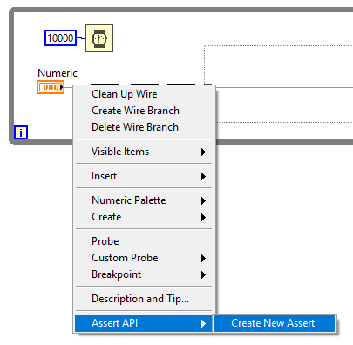

Once through this you’ll land on the Build Assert VI dialog (or build multiple asserts dialog, but start with building a single one, less room for mistakes….)

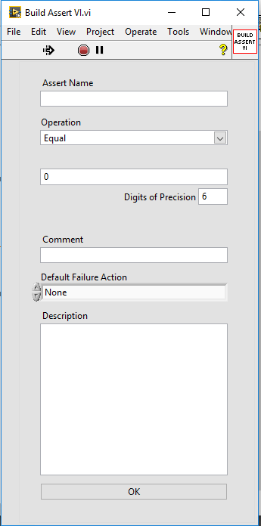This dialog box will reconfigure based on the data type of the wire selected.

* The Operation string combo box will update its selectable operations to be things like greater than, less than, equals for all numeric data types, or contains, starts with, ends with for string data types. Booleans can just equal or not equal the answer.
* Based on the operation selected, the number of comparison values and their types will be made visible or invisible (Greater Than Less Than requires 2 comparison values, all other numeric tests require 1)

For floating point numeric equals and not equals tests, the digits of precision defines how closely the number must match.

Assert Name, Comment, Default Failure Action and Description are all constant fields which should be defined for any assert created.

When you press OK, a new vi is scripted with these values and stored in a sub-folder of the vi’s directory, then added to the code.

The assert vi’s icon is also updated so the colour matches the data type (float, integer, string or boolean)

Once the asserts have been created and added to the code, you can run it.

Then go into the tools menu and find Assert API >> Start Assert Display…

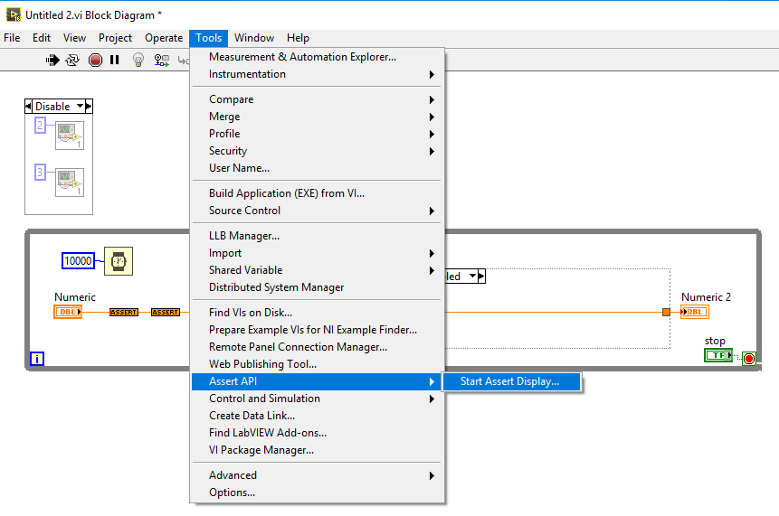

This will open the Assert Display, where you can view the values of asserts and take action if they fail.

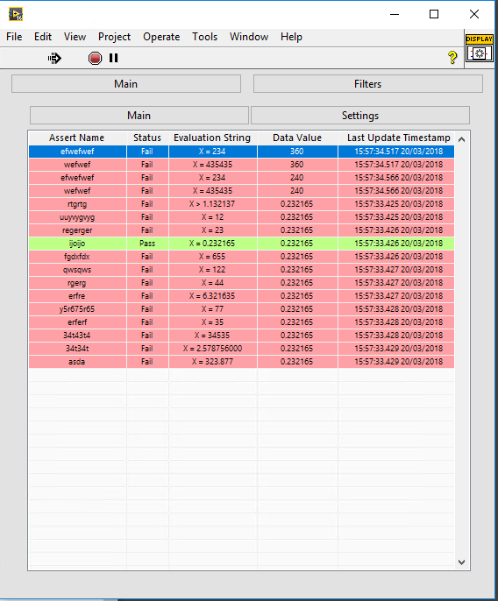

Right click on the column names at the top allows you to change what information is shown in a specific column.

Right click on an assert line brings up a menu, where you can either show the assert vi in place, or change what happens if it fails.

Filters allows you to filter in or out, different assert vi’s so if you have a large number of assert vi’s currently active, you can restrict the list a bit.